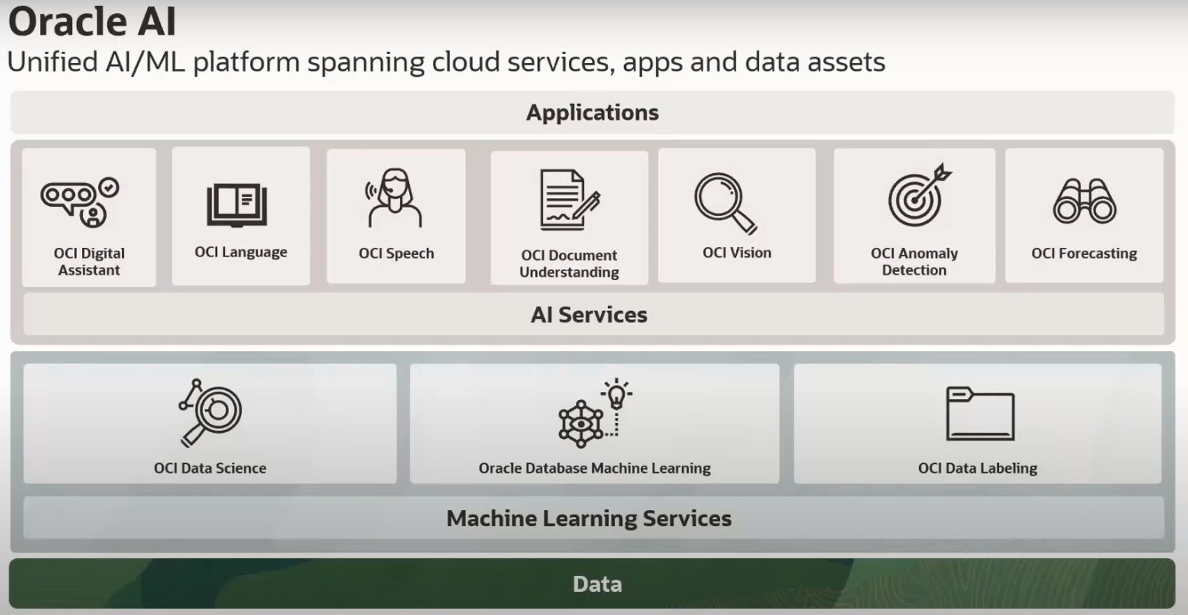

**Data:**

* Oracle AI has several different services that utilize structured and unstructured data.

**Machine Learning Services:**

* **OCI Data Science** allows us to rapidly build, train, deploy, and manage machine learning models.
* **Oracle Database Machine Learning** allows us to uncover hidden patterns and insights on enterprise data.
* **OCI Data Labelling** helps to build data sets that can be used to train machine learning models.

**AI Services:**

OCI Digital Assistant, OCI Language, OCI Speech, OCI Document Understanding, OCI Vision, OCI Anomaly Detection, OCI Forecasting - these services are targeted toward developers who are looking to add AI to their applications, but they may or may not have the data science background to be able to do this from scratch.

**Document Understanding**:

Enterprise document data has significant value related to core business activities and their customers. To gain business and customer insights effectively and at scale from this data, document analysis capabilities are needed. Some core capabilities include classifying documents, extracting text, extracting table information, and extracting key-value pairs from documents. Building these machine learning algorithms from scratch requires extensive time, data, and data science expertise, but OCI Document Understanding gives organizations ready access to these models and capabilities.

- Oracle Cloud Infrastructure (OCI) Document Understanding is an AI service that enables developers to extract text, tables, and other key data from document files through APIs and command line interface tools. With OCI Document Understanding, you can automate tedious business processing tasks with prebuilt AI models and customize document extraction to fit your industry-specific needs.

* one of the Oracle AI Services, the top layer of machine learning services.
* a powerful and easy-to-use tool for developers to extract text, tables, and other types of key information from any type of document.
* Document Understanding is a serverless, multitenant service, accessible using the **Console, REST APIs, SDK, or CLI**.
* You can upload documents to detect and classify text and objects in them. You can process individual files or batches of documents using the ProcessorJob API endpoint.

The following pretrained models are supported:

